9/5/2022

Dhruba Saha

B.Sc Sem-v

B.Sc-(sem-v)-Comp-o4

VB-2480 of 2017-18

Digital Image Processing

Assignment 1

1. Read and display image

Code:

%Read and display image

clear

img = imread("src\rgb.jpg");

figure('name','Read and display image','NumberTitle','off');

imshow (img);

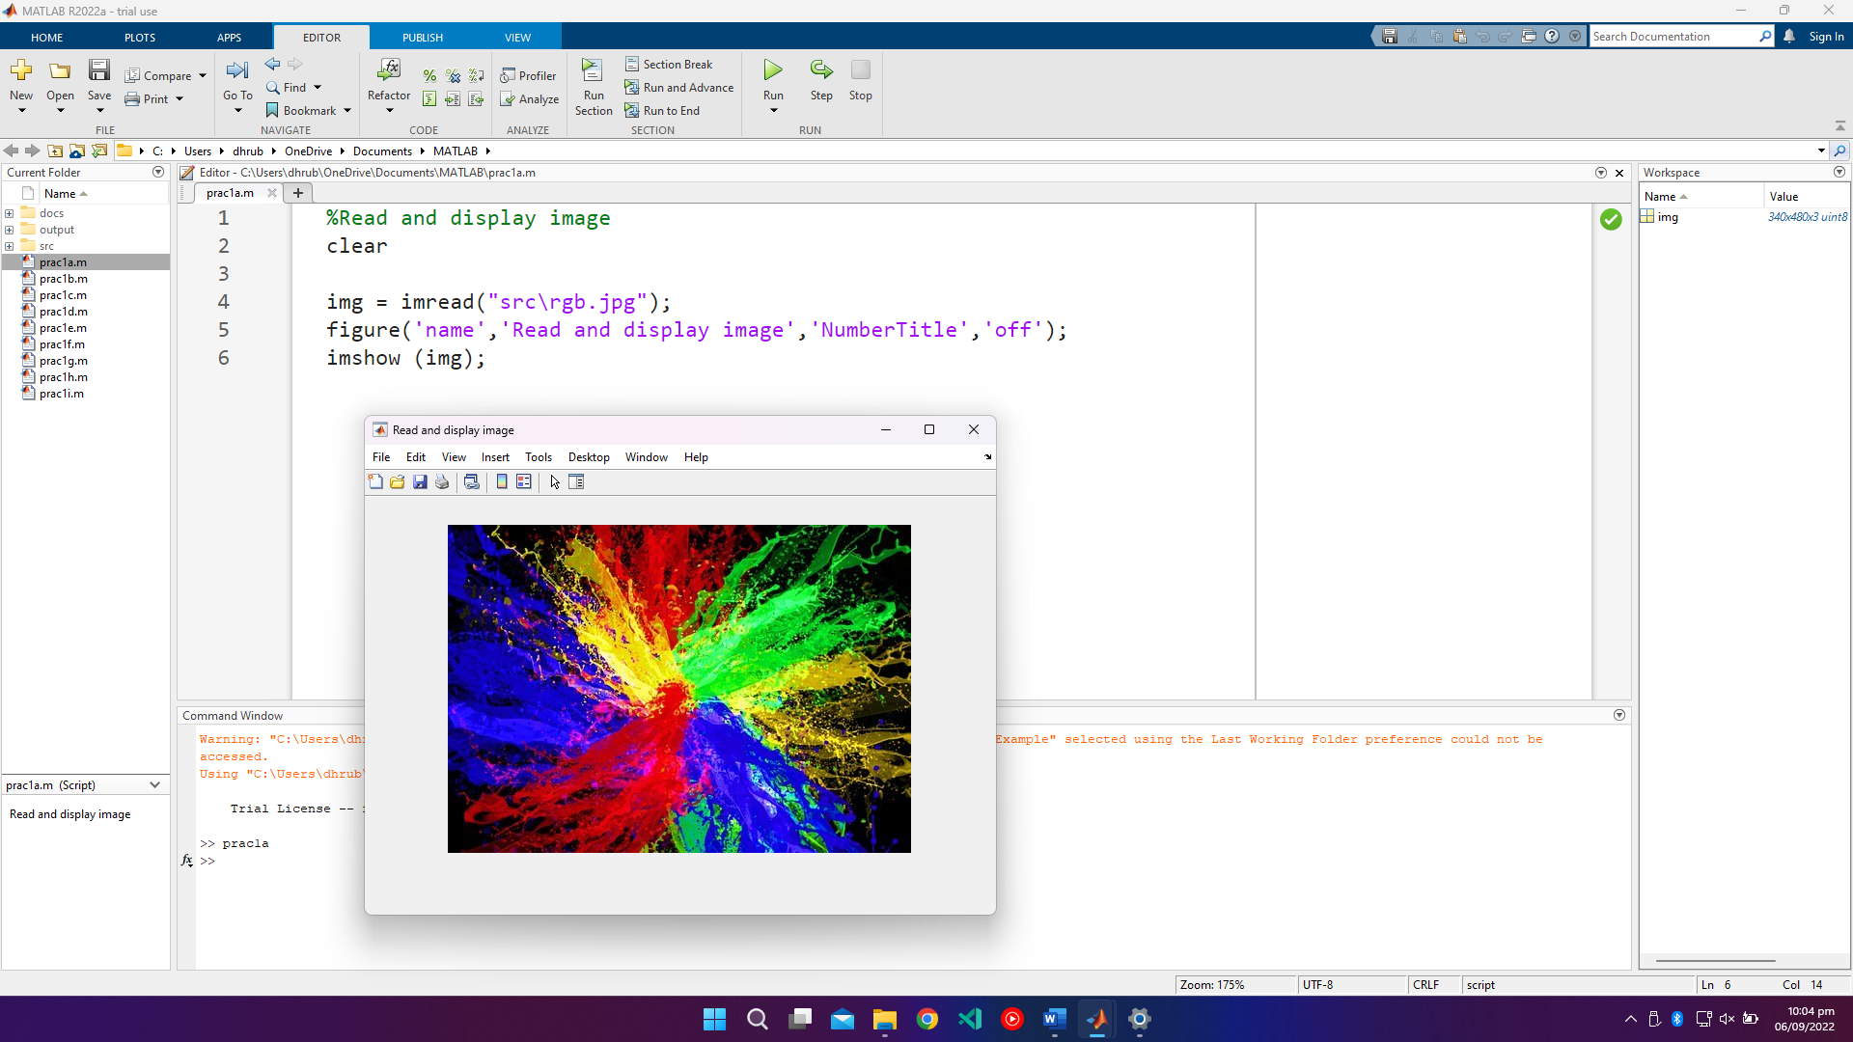

1. Read a gray-scale image of 256x256, add 20 with every intensity value. Write it to another image file and show it.

%Read a gray-scale image of 256x256, add 20 with every intensity value. Write it to another image file and show it.

clear

img1 = imread("src\8-bit-256-x-256-Grayscale-Lena-Image.png");

img2 = mod(img1+20,256);

imwrite(img2,"output\output1.png");

img3 = imread("output\output1.png");

figure('name','Gray-scale image of 256x256 having added 20 with every intensity value','NumberTitle','off');

subplot(1,2,1)

imshow(img1);

title('Original')

subplot(1,2,2)

imshow(img3);

title('Output(Intensity +20)')

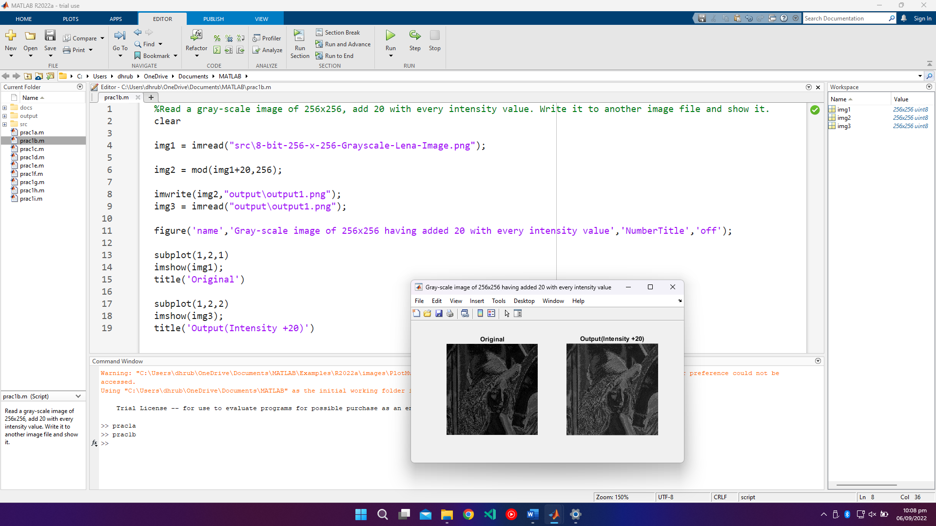

1. Resize given image

%Resize given image

clear

img1 = imread("src\images.jpg");

img2 = imresize(img1,100);

img3 = imresize(img1,0.5);

figure('name','Resize given image','NumberTitle','off');

subplot(1,3,1)

imshow(img1);

title('Original')

subplot(1,3,2)

imshow(img2);

title('Upscaled')

subplot(1,3,3)

imshow(img3);

title('Downscaled')

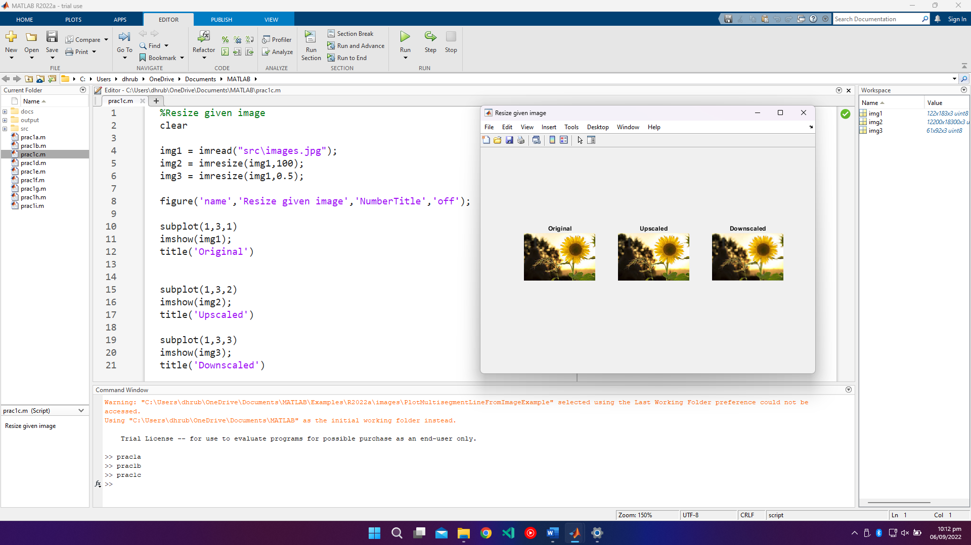

1. Show RGB color components separately of an image (in color)

%Show RGB color components separately of an image (in color)

clear

img = imread("src\rgb.jpg");

figure('name','RGB color components of an image','NumberTitle','off');

[red, green, blue]=imsplit(img);

allblack = zeros(size(img, 1, 2), class(img));

redimg = cat(3,red,allblack,allblack);

greenimg = cat(3,allblack,green,allblack);

blueimg = cat(3,allblack,allblack,blue);

subplot(1,4,1)

imshow(img);

title('Original')

subplot(1,4,2)

imshow(redimg);

title('Red')

subplot(1,4,3)

imshow(greenimg);

title('Green')

subplot(1,4,4)

imshow(blueimg);

title('Blue')

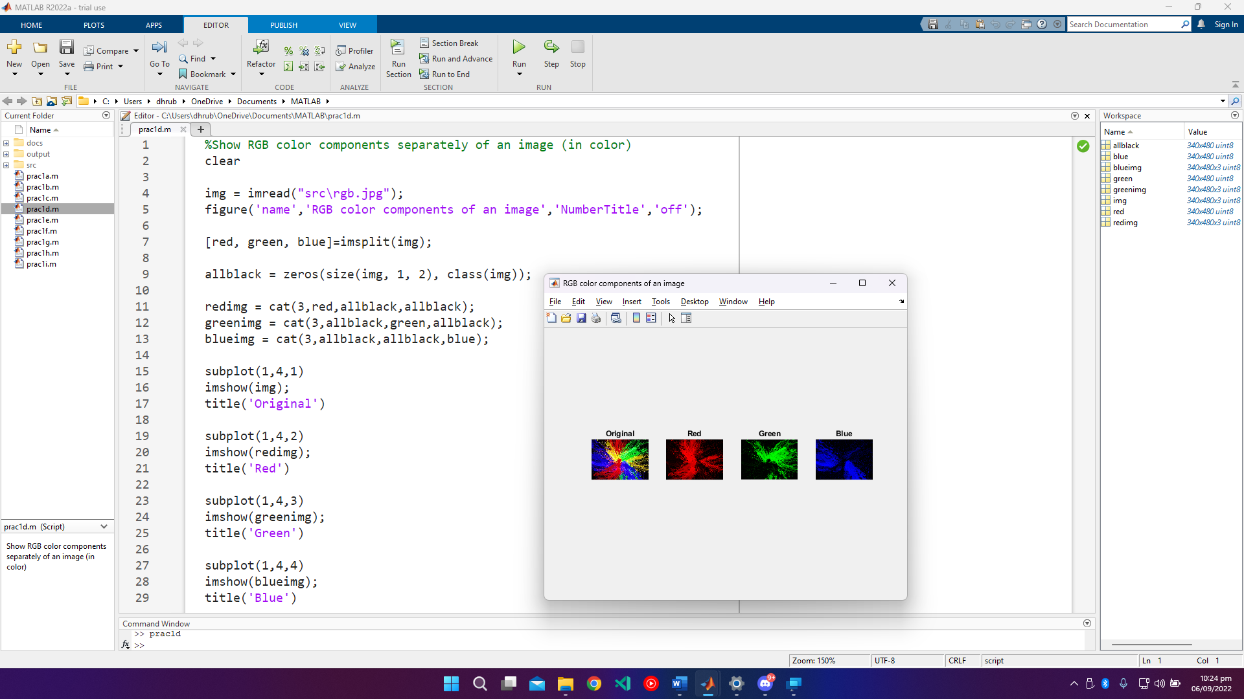

1. Convert given color image into gray-scale image

%Convert given color image into gray-scale image

clear

figure('name','Convert color image to gray-scale image','NumberTitle','off');

img1 = imread("src\rgb.jpg");

img2 = rgb2gray(img1);

subplot(1,2,1)

imshow(img1);

title('Color image')

subplot(1,2,2)

imshow(img2);

title('Gray-scale image')

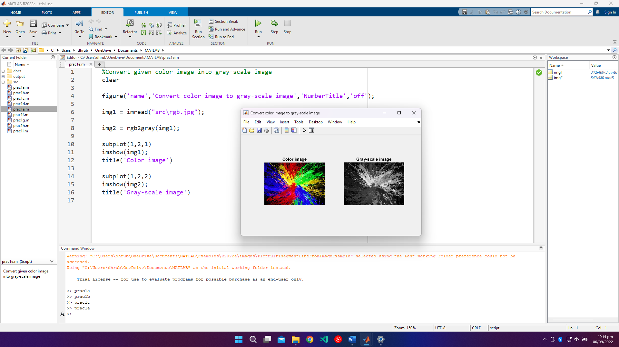

1. Convert given color/gray-scale image into black & white image

%Convert given color/gray-scale image into black & white image

clear

figure('name','Convert color/gray-scale image to black & white image','NumberTitle','off');

img1 = imread('src\rgb.jpg');

img2 = imread('src\8-bit-256-x-256-Grayscale-Lena-Image.png');

img3 = im2bw(img1,0.5);

img4 = im2bw(img2,0.1);

subplot(2,2,1)

imshow(img1);

title('Color image')

subplot(2,2,2)

imshow(img2);

title('Gray-scale image')

subplot(2,2,3)

imshow(img3);

title('Black & white image')

subplot(2,2,4)

imshow(img4);

title('Black & white image')

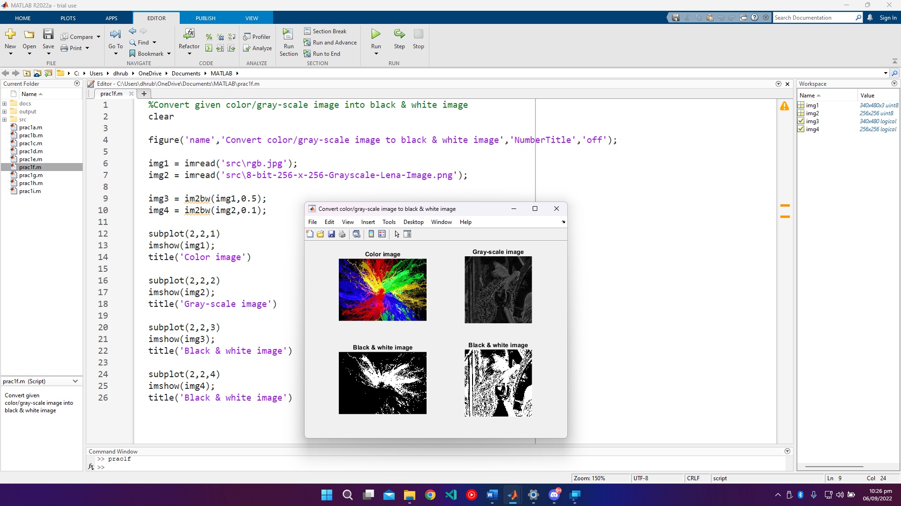

1. Write given 2-D data in image file

%Write given 2-D data in image file

clear

img = zeros(200);

imwrite(img,"output\output2.png");

